**Exercise 2 : E-commerce Platform Search Function**

**🡪 Understanding Asymptotic Notation and Big O Notation**

**1. Asymptotic Notation**

* **Big O Notation:**  
  Big O notation describes the upper bound of an algorithm’s running time as the input size grows. It helps compare the efficiency of algorithms regardless of hardware or implementation details.
* **Best, Average, and Worst Case:**
  + **Best Case:** The minimum time required (e.g., finding the first element).
  + **Average Case:** The expected time over all possible inputs.
  + **Worst Case:** The maximum time required (e.g., element not present).

🡪**Analysis**

* **Time Complexity:**
  + **Linear Search:** O(n) in the worst case (must check every product).
  + **Binary Search:** O(log n) in the worst case (halves the search space each time).
* **Suitability:**
  + **Linear Search** is simple but slow for large datasets.
  + **Binary Search** is much faster but requires the array to be sorted.
  + For an e-commerce platform with many products, **binary search** is more suitable for fast performance, provided the data is kept sorted.
* **Implementation of E-Commerce Platform Search**

1. **Creation of Product Class :**

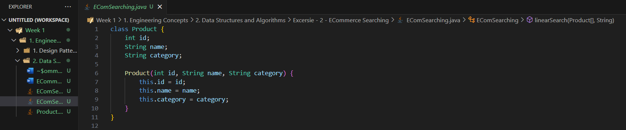

1. **Implementation of Searching Algorithms**
   1. **Linear Search :**

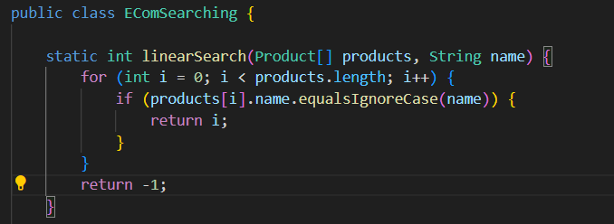

* 1. **Binary Search with Sorting array by name (Bubble Sort)**

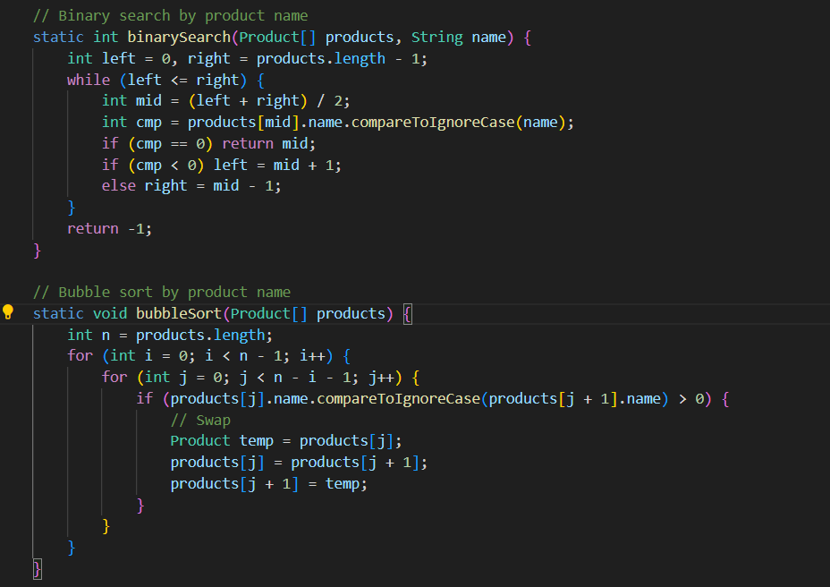

1. **Output**

